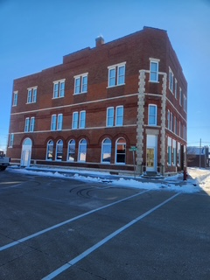
🌟 Now Leasing in the Historic Loomis Building – Farley, Iowa! 🌟
Built in 1890 and completely remodeled, the iconic Loomis Building blends historic charm with modern luxury — and newly finished apartments are now available!
🏡 Available Units:
✨ 6 beautiful 1-bedroom apartments
✨ 2 spacious 2-bedroom apartments
🔧 Modern Features & Upgrades:
• Brand-new Whirlpool appliances
• Kohler fixtures & Delta faucets
• In-unit washer & dryer
• Electric furnace with central air
• Electric water heater
• All new windows
• Solid core doors for added privacy
• Walk-in tile showers
• Stunning quartz countertops
• Self-closing cabinets
• Preserved original hardwood floors
• Convenient keyless entry
These thoughtfully designed apartments offer comfort, efficiency, and style — all within one of Farley’s most historic buildings.
📍 Loomis Building — Farley, Iowa
If you're looking for modern living with historic character, this is the perfect place to call home!
📞 Contact Bill Brown @ 563-543-3892 for availability, pricing, and tours!

Two Bedroom
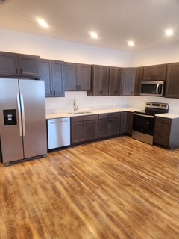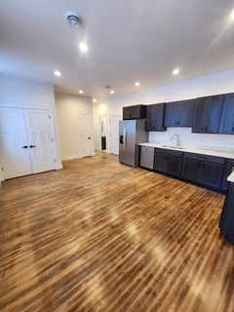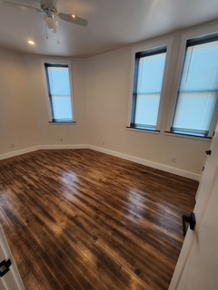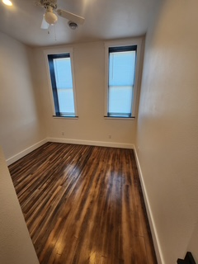

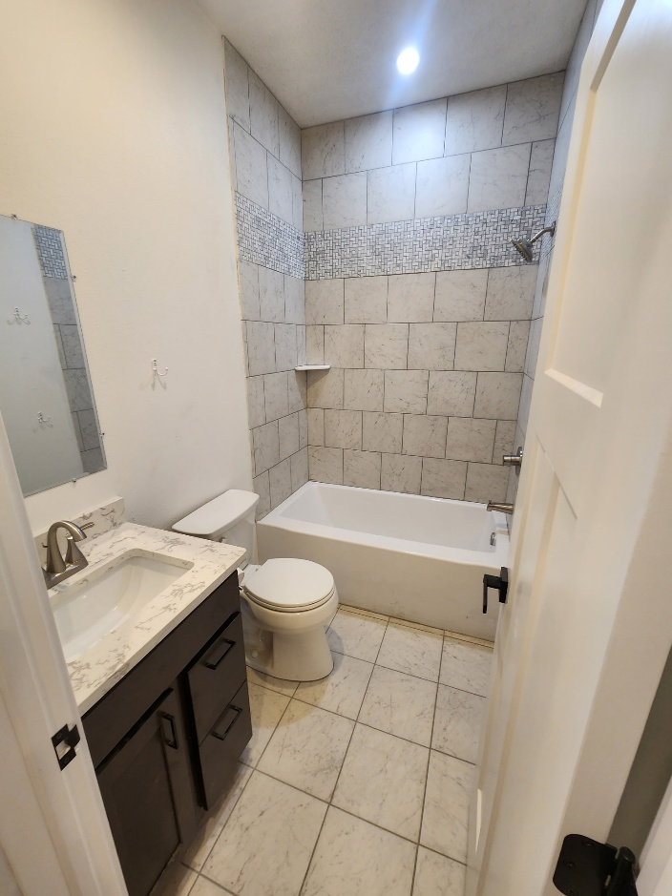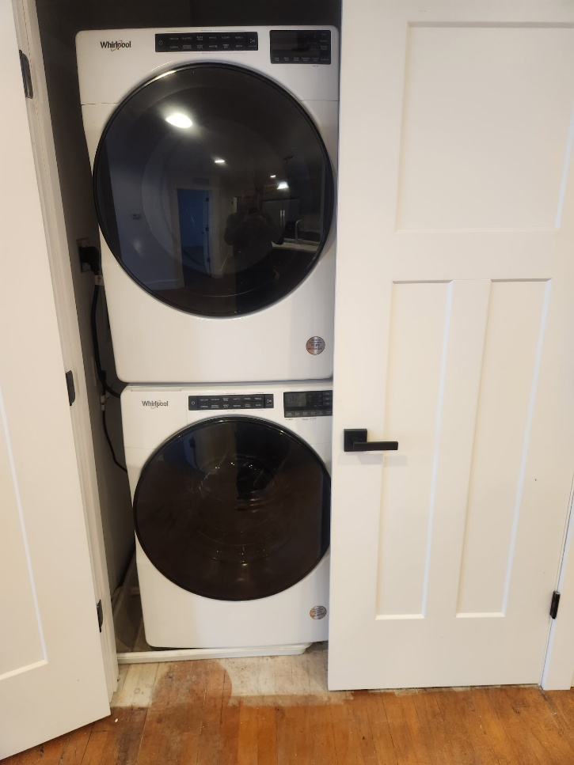

One Bedroom
